

# R AND POWER BI PROJECT

Bernerditta | R and Power BI Project | 11/12/2024

Contents

Step1: Initial Exploratory Analysis 1

Step2: Clean Data ​ 2

Step 3: Exploratory Data Analysis ​ 3

Step4: Final Power BI dashboard View 3

# Step 1: Initial Exploratory Analysis

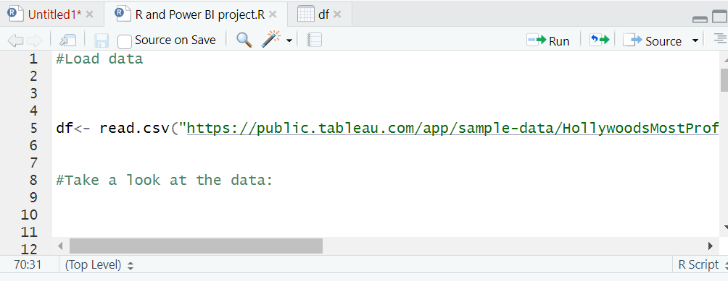

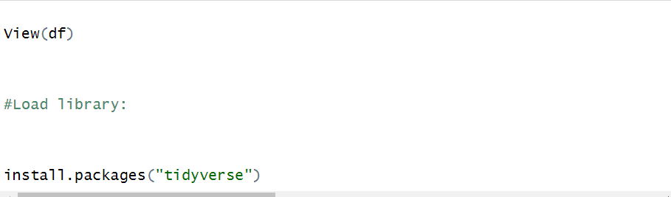

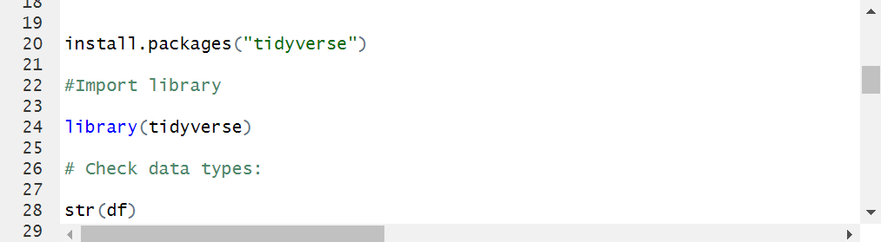

# Step 2: Clean Data ​

# Step 3: Exploratory Data Analysis ​



R Plot Output :

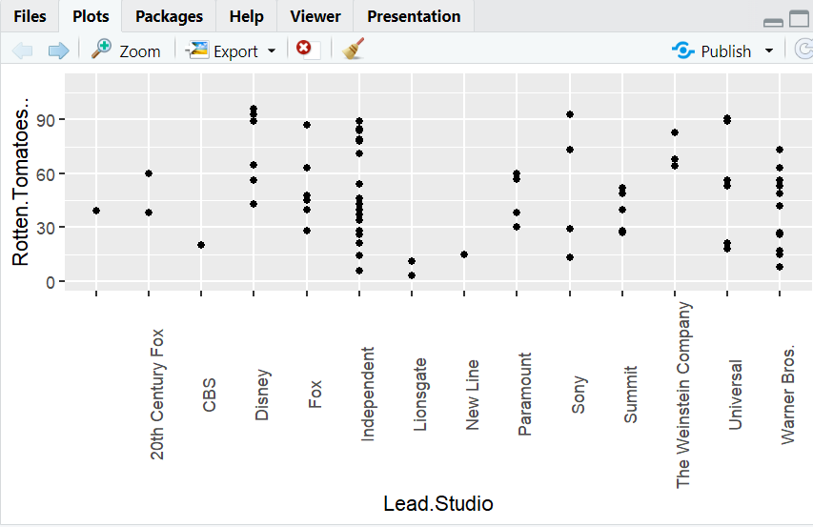

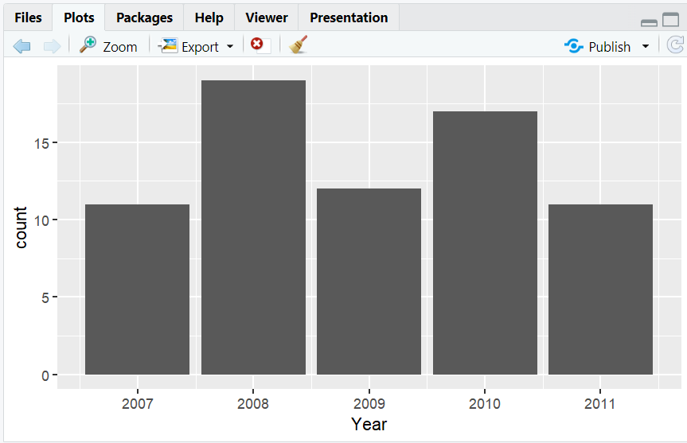

# Step 4: Final Power BI dashboard View

